Paart 1 incorrect

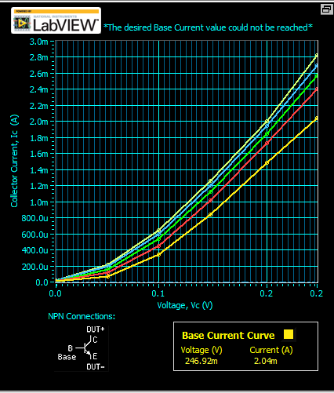

Part 2 (correct)

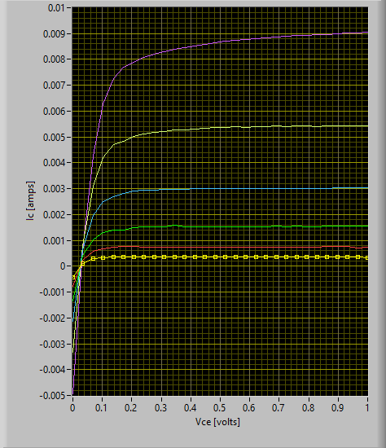



Part 3

(a)

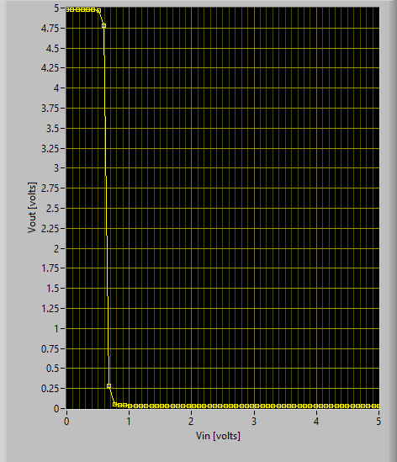

(b)

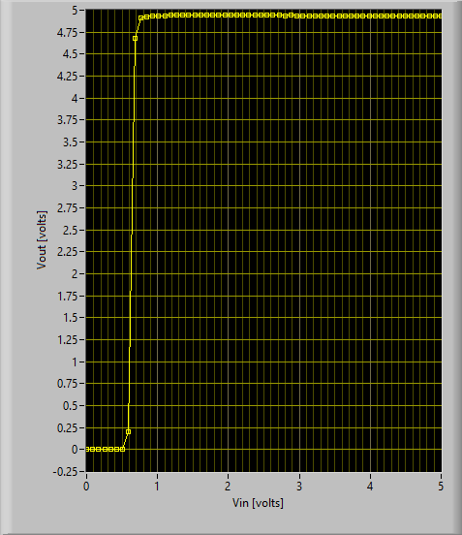

Data (b)

Part (c) graph

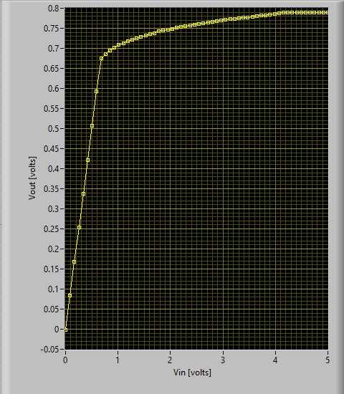

**What to do in your lab report?**

Discuss, at what Vin the output voltage starts to drop appreciably? How does this compare to 0.7V, the turn on voltage of a Si PN junction? Recall that the base-emitter junction is essentially a PN junction, only the electron current gets transported to the collector.

Identify the 3 distinct regions of operation (cutoff, forward active, reverse active or saturation) on the Vout-Vin curve.

Plot IC and IB versus Vin. Explain how beta, the ratio of IC/IB, changes with Vin.

Part 4

Measure and record in a table the values of VCE, VBE, VBC, IB and IC when the LED is on and when it is off. In order to determine IB, measure the voltage drop across RB using either the Fluke DMM or the ELVIS DMM, and use Ohm’s law to calculate the base current. If the onboard voltmeter is used it will be necessary to disconnect the current meter from the collector. Can you confirm that the BJT is in saturation when the LED is on, and in cutoff when the LED is off? (Hint: In saturation, both junctions should be forward biased. In cutoff, both junctions should be reverse biased.)

Vce .049

Vbe .784

VBC .739

Ib .008 a

Ic 0

LED 2.014 v, .013 a

Replace Rb with a 1 k\Omega resistor. Replace the LED and 330 ohm resistor with a fan and repeat. Observe the fan polarity (black wire should be connected to the collector of the BJT, red to the DMM). Measure and record VCE, VBE, VBC, IB and IC when the fan is on and when it is off. Does the transistor still saturate when the fan is on?

Don’t do